**This is the user guidance page for Graph Recursion Visualizer**

How to open the visualizer webpage?

1. Download Git SCM from <https://git-scm.com/downloads>

1. Open Git CMD application

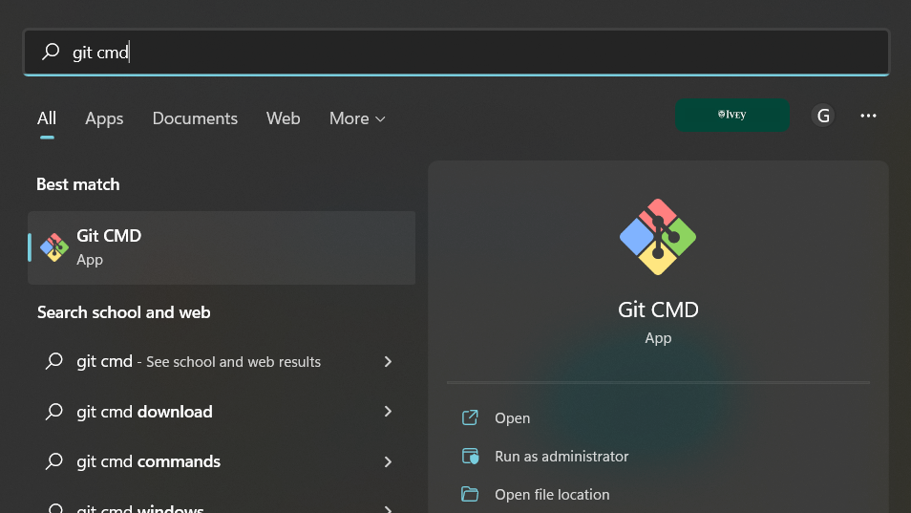

1. Create webserver at index.html folder
   1. ***cd*** to the folder
   2. enter ***python -m http.server*** to create webserver
   3. Open browser, enter ***localhost:8000*** and click Enter to access the webpage (in this case is port 8000)

1. Click button to execute input code and observe graph and stack animation
2. Click to terminate execution
3. Click to restart from beginning of traversal animation
4. Click to go backward one step of traversal
5. Click to go forward one step of traversal
6. Click to view two sample algorithm codes: Depth first search and Cyclic detection
7. JavaScript editor:
   1. Must enter two comment line to transfer to push / pop action (shown as // DFS: in and //DFS: out in example, customizable to whatever comment line desired)
   2. Embedded useful functions:
      1. Change node name: node.name = ‘string’; && node.name = node.id();
      2. Change node weight: node.weight = int; && node.weight ++;
      3. choose which node to begin with: dfs(nodes.getElementById(3));
      4. setup two more attributes for each node: id [ name=string, weight=digit];
8. Click to enter graph connect node
   1. Right click to delete node or edge
   2. Click one node and hold to another node to create edge
   3. Double left click to edit edge/node data
9. Click to enter move mode, click and hold to move graph location
10. Click to allow adding new nodes:
    1. Left click anywhere on graph section to form new node with attribute
11. Change form to directed or undirected
12. Click to view list of layouts and change layout
13. Click to activate View Source (Image on second page)
14. Click to activate view graph source mode (image below)
    1. Click upload to upload txt or gv extension file with DOT language format as below
    2. Click download to download existing graph into a gv file
    3. Click reset to become default graph
    4. Click save to save current graph data
    5. Click cancel to unblock stack execution panel

